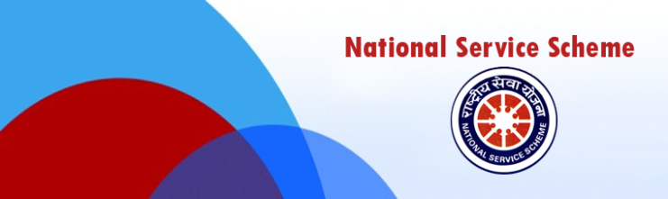

REPORT
ON
“EK BHARAT SHRESHTHA BHARAT” (EBSB)

SUBMITTED BY:
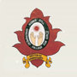
NSS UNIT, POST GRADUATE GOVERNMENT COLLEGE FOR GIRLS, SECTOR 42 CHANDIGARH

EK BHARAT SHRESHTHA BHARAT
Ek Bharat Shreshtha Bharat” was announced by Hon’ble Prime Minister on 31st October, 2015 on the occasion of the 140th birth anniversary of Sardar Vallabhbhai Patel. Through this innovative measure, the knowledge of the culture, traditions and practices of different States & UTs will lead to an enhanced understanding and bonding between the States, thereby strengthening the unity and integrity of India.
All States and UTs will be covered under the programme. There will be pairing of States/UTs at national level and these pairings will be in effect for one year, or till the next round of pairings. The State/UT level pairings would be utilized for state level activities. District level pairings would be independent of the State level pairings. The activity will be very useful to link various States and Districts in annual programmes that will connect people through exchanges in areas of culture, tourism, language, education trade etc. and citizens will be able to experience the cultural diversity of a much larger number of States/UTs while realizing that India is one.

OBJECTIVES OF EK BHARAT SHRESHTHA BHARAT
The broad objectives of the initiative are as follows:-
- To CELEBRATE the Unity in Diversity of our Nation and to maintain and strengthen the fabric of traditionally existing emotional bonds between the people of our Country;
- PROMOTE the spirit of national integration through a deep and structured engagement between all Indian States and Union Territories through a year-long planned engagement between States;
- To SHOWCASE the rich heritage and culture, customs and traditions of either State for enabling people to understand and appreciate the diversity that is India, thus fostering a sense of common identity;
- TO ESTABLISH long-term engagements and
- TO CREATE an environment which promotes learning between States by sharing best practices and experiences.

According to engagement matrix between states and UTs our Chandigarh was paired with Dadra & Nagar Haveli

As per meeting conducted on 9th November 2019 in Dev Samaj College Sec-36, Chandigarh by State NSS Cell, Chandigarh regarding activities to be observed in each and every NSS unit of different colleges, Following Activities were organized by NSS unit of Post graduate Govt. College for Girls Sector -42, Chandigarh with under mentioned aim.
Aim: To induce a sense of responsibility & ownership among the NSS volunteers for the nation as a whole through these close cross-cultural interactions as it intends to build up the inter-dependence matrix unequivocally.

NSS Volunteers Covered: 150

Activity 1- Screening films on Dadra and Nagar Haveli
A short movie was shown to NSS volunteers of the college to know and understand the history of Dadra and Nagar Haveli that begins with the defeat of the Koli chieftains of the region by the invading Rajput kings. In the year 1262 a Rajput prince from Rajasthan named Ramsinh established himself as the ruler of Ramnagar, the present-day Dharampur, which consisted of 8 parganas (group of villages) and assumed the title Maharana. Nagar Haveli was one of the parganas, and its capital was Silvassa.
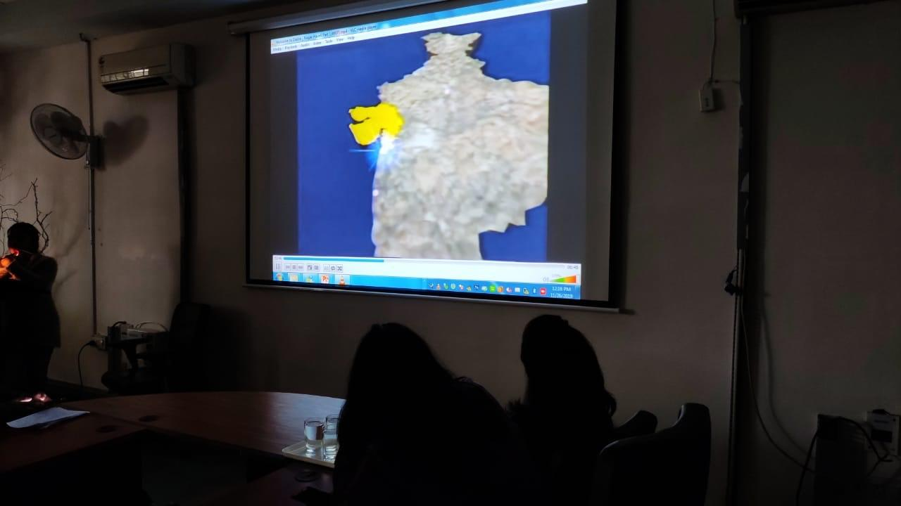
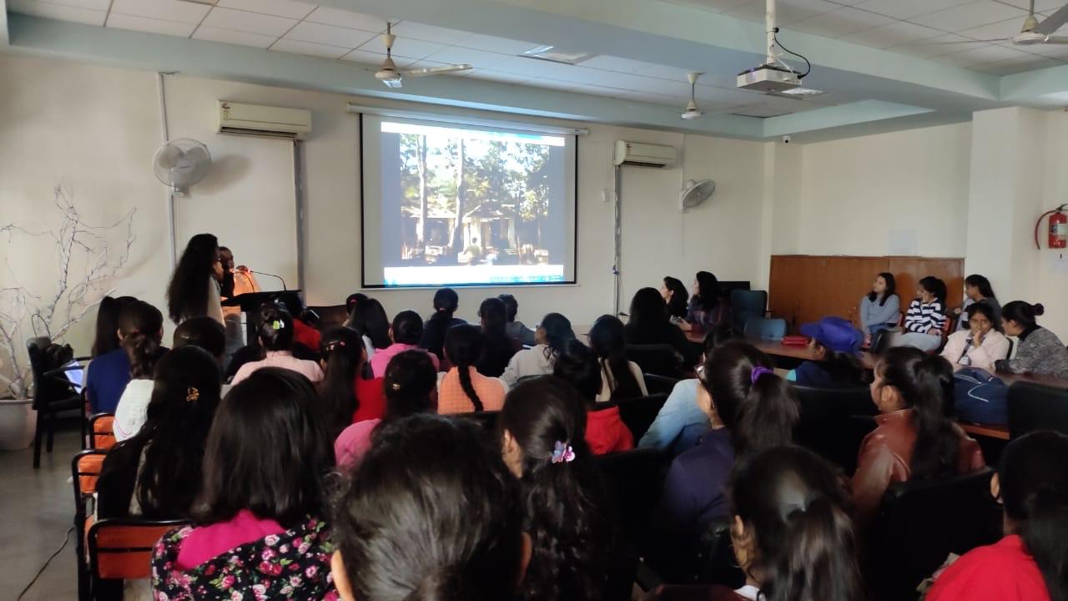
From 1954 to 1961, Dadra and Nagar Haveli was administered by a body called the Varishta Panchayat of Free Dadra and Nagar Haveli, with administrative help from the government of India. Although it enjoyed de facto independence, Dadra and Nagar Haveli were still recognized internationally (e.g. by the International Court of Justice) as Portuguese possessions. Areas important from tourism point of view were also covered in this short film.
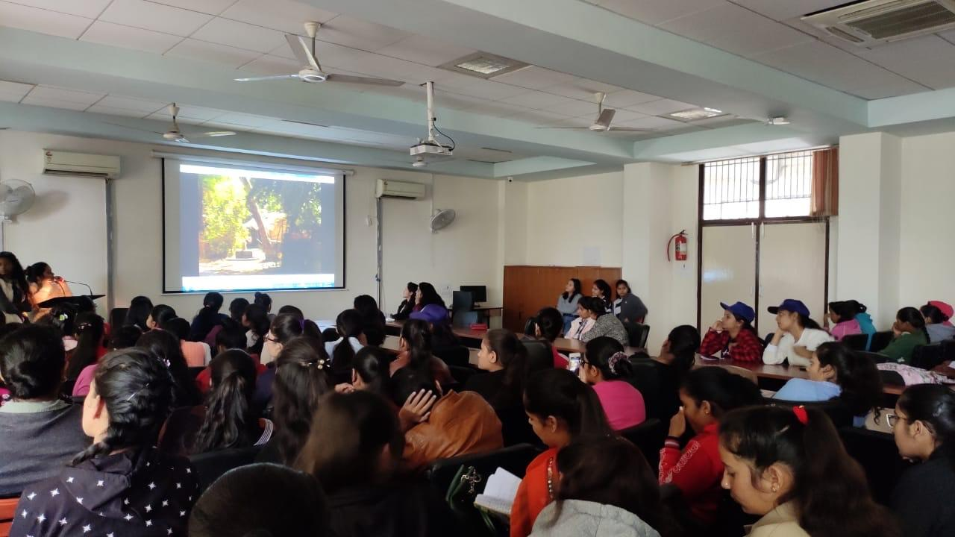
ACTIVITY 2- DEBATE AND DISCUSSIONS ON LIFESTYLE AND LANGUAGES OF DADRA AND NAGAR HAVELI AND CHANDIGARH
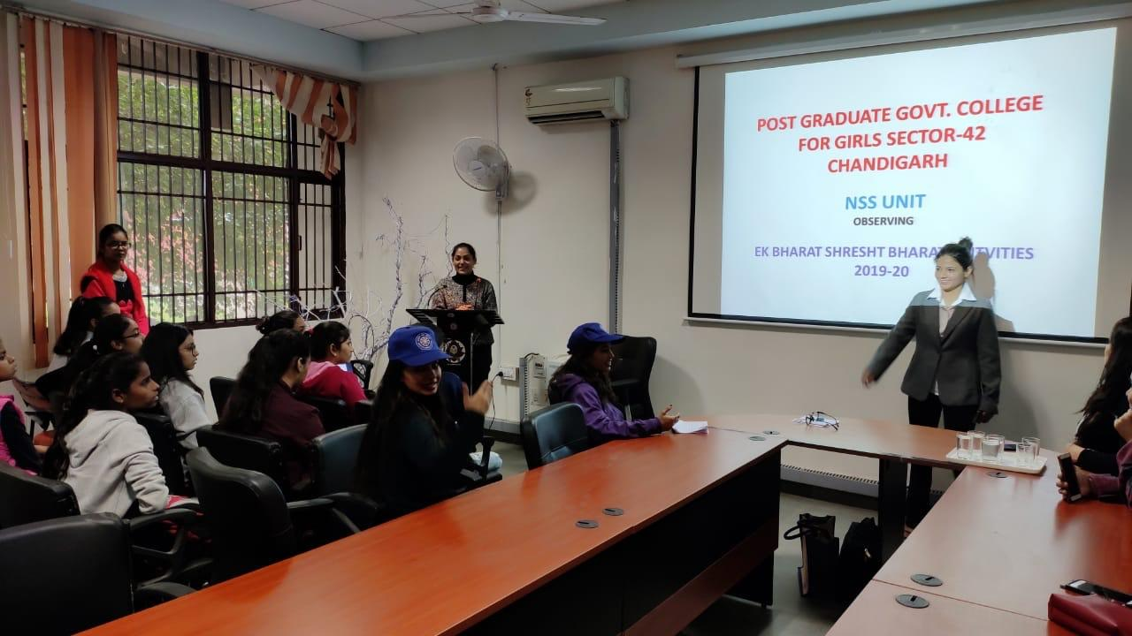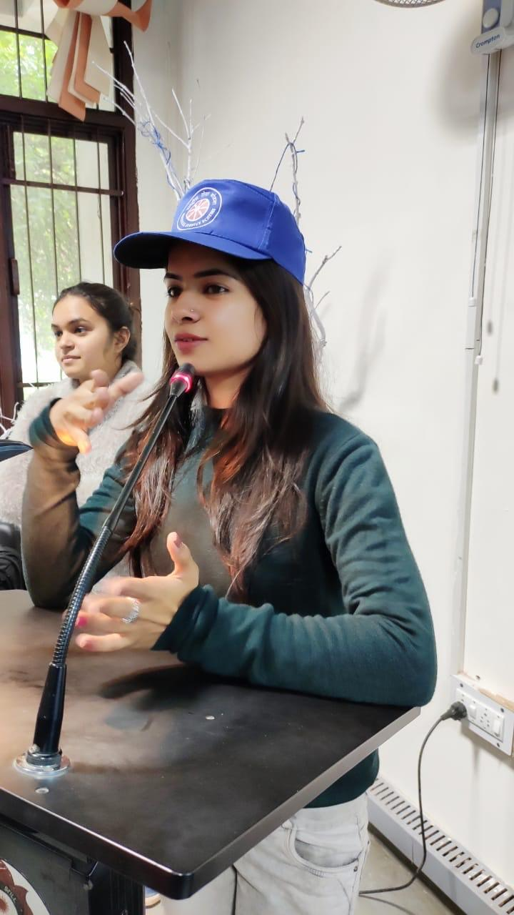
Debate on the lifestyle and languages of both paired UTs that is Dadra and Nagar Haveli and Chandigarh was also organized. Volunteers are also learning the Gujrati language. The conversation sentences learned till date were also discussed. NSS volunteers are really very excited about the activities going under Ek Bharat Shreshta Bharat.

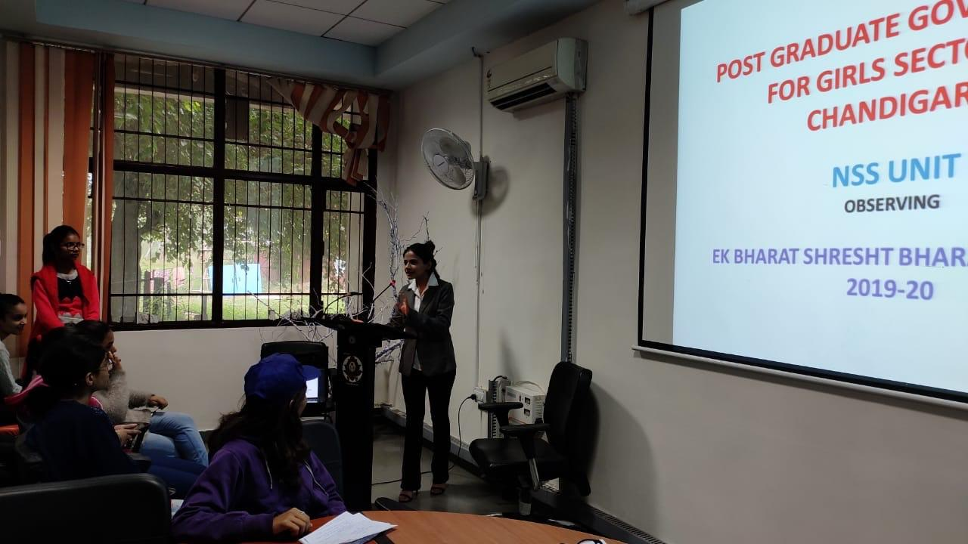

CONCLUSION
Ek Bharat Shreshtha Bharat” programme of Govt. of India encourages learning among the students and provide them exposure to culture, traditions, sports and language of the partner States. It emphasizes on unity in Diversity of our Nation and help to maintain and strengthen the fabric of traditionally existing emotional bonds between the people of our Country. Therefore it promote the spirit of national integration through a deep and structured engagement between all Indian States and Union Territories

